**Security Analysis Report**

**We have Implemented diff Security Tests:**

We did our project analyzing tests on <https://observatory.mozilla.org/analyze/>

1. HTTP Observatory
2. TLS Observatory
3. SSH Observatory
4. Third Party Test

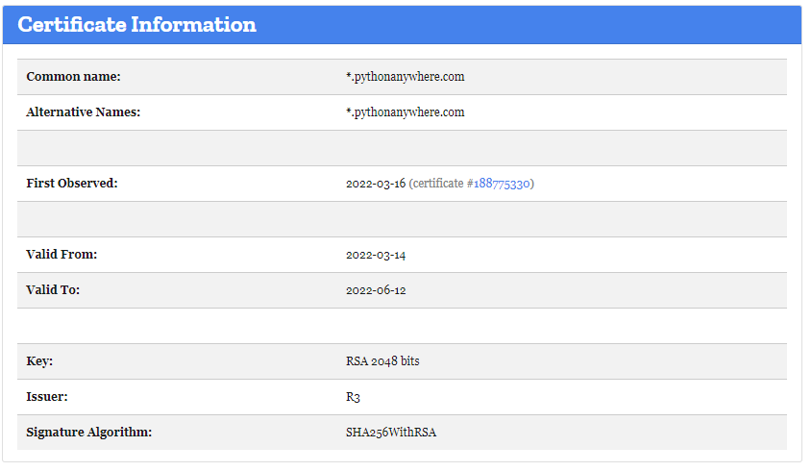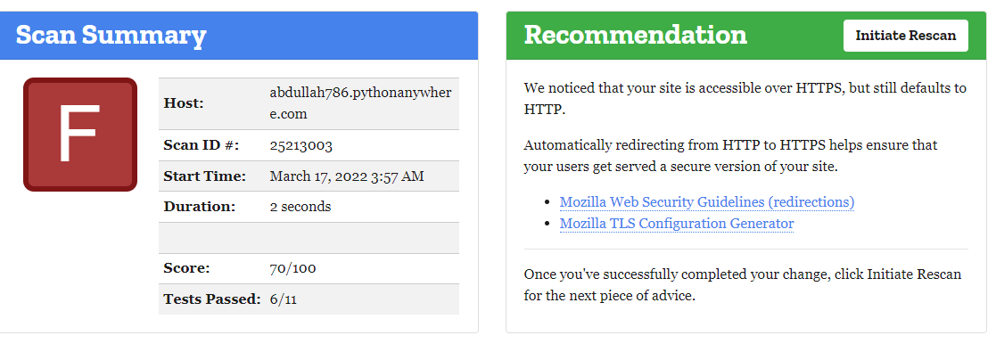**Note:** we are using free platform it’s on trial that’s why we have not connected any domain and any SSL certificate that’s why we are gaining some test fail.

